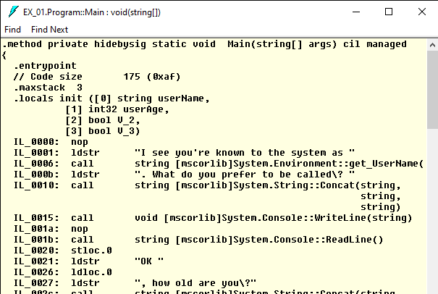

This is the Common Intermediate Language (CIL). CIL is a part of an assembly and, “is not compiled to platform-specific instructions unless absolutely necessary,” according to Pro C# 7. I took a look at the CIL for the Main method in my EX_01 project and was able to see how the code was stored and how it looked if it were running through this CIL. I’m able to tell what some actions being performed are, such as call, and ldloc.0, which would be the {0} part in Console.WriteLine(“stuff stuff stuff {0}”, <definition of what {0} is>)

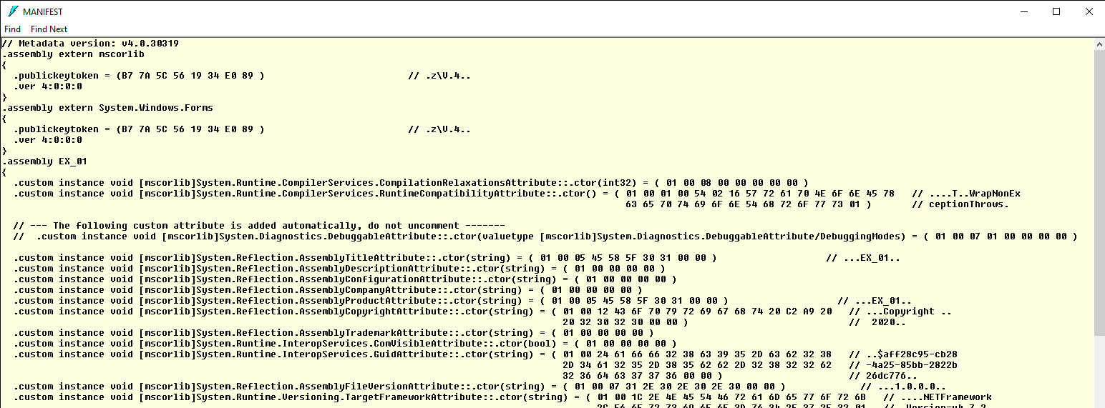

This is the manifest. The manifest helps describe assemblies in a project. For example, this screenshot shows the inclusion of the Systems.Windows.Forms assembly, which was used to create a message box in EX_01. This image helps show what the beginning of a manifest looks like and how some of the externally references assemblies are incorporated in the project.

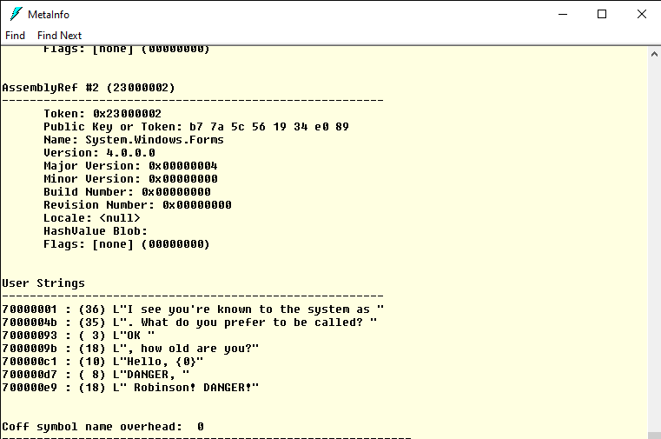

This is the metadata. The metadata is contained in an assembly and assists in the description of all the different types within. This screenshot shows two things: some data regarding the System.Windows.Forms reference that was included in this project, as well as different user strings. The information regarding use strings is much more descernable, giving the length of the string prior to listing the string.